A Panel on:
Interfaith and Environmental Cooperation
Inspired by the Common Biological/Cultural Heritage, “Home”

DATE: October 2, 2019, Wednesday
TIME: 6 – 7:30 pm
PLACE: AL Auditorium, Huston-Tillotson University
SPONSORS:
Center for Religious Life, Huston-Tillotson University
Arthur Vining Davis Foundation
PANELISTS:
Dr. Amanda Masino, geneticist, Huston-Tillotson University
Dr. James Kraft, philosophy and religious studies, Huston-Tillotson
The Venerable Terry Cortés-Vega, Buddhist priest in the tradition of
Thich Nhat Hanh
Dr. Jagannath Vedula, Founding Trustee and community outreach,
Austin Hindu Temple and Community Center
Sheikh Attiah Emara, Islamic Center of Greater Austin
Pastor Austin Fischer, Vista Community Church, Temple
DEDICATION TO:
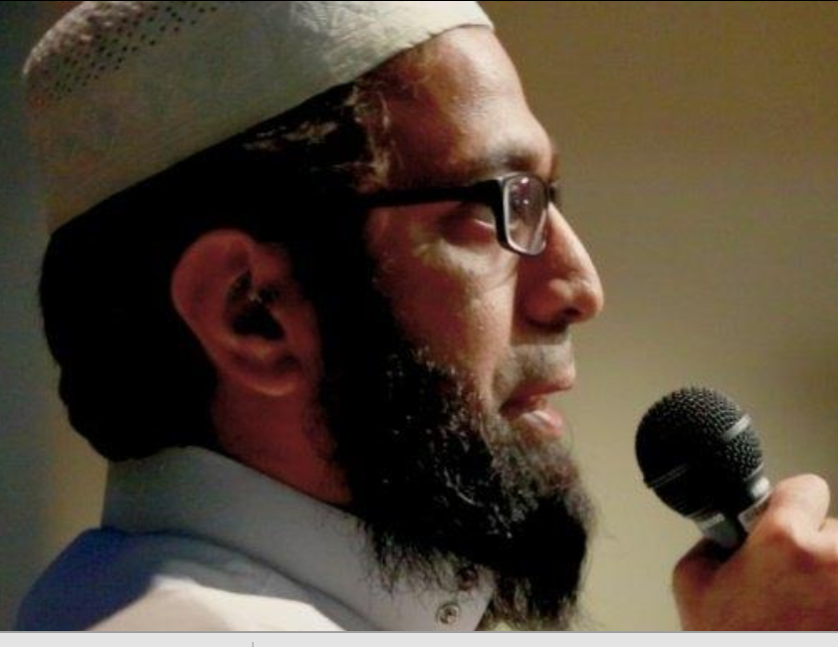
Sheikh Mohamed-Umer Esmail, recently passed Muslim leader of interfaith dialogue in Austin.
Dr. and Venerable David Zuniga will give a tribute
to his interfaith work and gracious will.

Finding in our religions expressions of our common biological/cultural heritage

People of different spiritual backgrounds can be inspired to understand and cooperate with each other using a philosophical approach called pluralism. Pluralism connects diverse religious/faith groups through unifying similarities, such as a shared ultimate reality, shared positive ends, and/or shared goals of civic life. We promote a new pluralist understanding called “home” pluralism based on the unifying similarities of the common “home” all human beings share due to our common heritage evolving in Africa. When vast philosophical/spiritual/cultural differences are viewed as made possible by, and expressing, this common “home,” suddenly and auspiciously, we reframe and transcend differences. We can attain respect for people of different identities, due to a common “home” from which those identities come. We are inspired to form relationships across diverse religious identities, because we feel connected to others by our common “home.” And we will work towards the common environmental good, because we have a common “home” to preserve.

We will present this concept of “home” pluralism to leaders of diverse faith communities and discuss the implications and applications of this new approach.
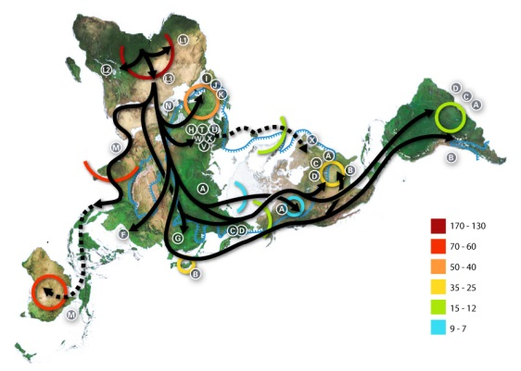
The paths Homo Sapiens’ human ancestors took out of Africa

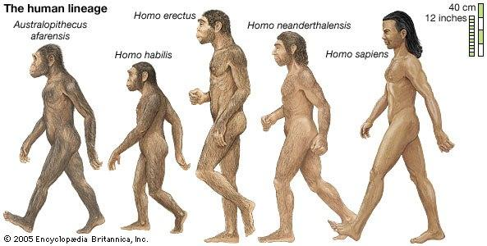

Worksheet that must be filled out for class assignment and, more importantly, deeper wisdom. Name: ________________________

For full credit, answer all the questions below with at least THREE complete, grammatically correct, sentences; and return to me after the panel or under my door at JM 212.

1) What do Dr. Masino and Dr. Kraft mean when they say all humans today share a common “home”?

2) Why are, or are not, convinced by the evidences given that humans evolved in Africa from Australopithecus Afarensis (picture on the other side of this page)?

3) Why do you agree, or not agree, with the following hypothesis of this panel (as expressed by Dr. Masino and Dr. Kraft):
If people from different religions/spiritualities/philosophies see that ALL humans today got crucial cognitive and social abilities from our common ancestors evolving in Africa for 3 million years (that is, from our common “home”), then there will be more cooperation among diverse peoples for preserving the environment that we all evolved in terms of, “home.”

4) What is distinctive about the Buddhist perspective that makes it open, or not open, to the idea that humans evolved in Africa from Australopithecus Afarensis getting cognitive and social abilities crucial for us today from the process of evolution?

5) Can Buddhists cooperate with religious others and care for the environment motivated by this idea of a common evolutionary heritage evolving in Africa from Australopithecus Afarensis, and if not, what does motivate Buddhist to these goals?

6) What is distinctive about the Hindu perspective that makes it open, or not open, to the idea that humans evolved in Africa from Australopithecus Afarensis getting cognitive and social abilities crucial for us today from the process of evolution?

7) Can Hindu cooperate with religious others and care for the environment motivated by this idea of a common evolutionary heritage evolving in Africa from Australopithecus Afarensis, and if not, what does motivate Hindus to these goals?

8) What is distinctive about the Muslim perspective that makes it open, or not open, to the idea that humans evolved in Africa from Australopithecus Afarensis getting cognitive and social abilities crucial for us today from the process of evolution?

9) Can Muslim cooperate with religious others and care for the environment motivated by this idea of a common evolutionary heritage evolving in Africa from Australopithecus Afarensis, and if not, what does motivate Muslims to these goals?

10) What is distinctive about the Christian perspective that makes it open, or not open, to the idea that humans evolved in Africa from Australopithecus Afarensis getting cognitive and social abilities crucial for us today from the process of evolution?

11) Can Christians cooperate with religious others and care for the environment motivated by this idea of a common evolutionary heritage evolving in Africa from Australopithecus Afarensis, and if not, what does motivate Christians to these goals?

